Explanation of Algorithms

Our situation is an interesting one. There are many algorithms and equations for the life of a star as a function of mass and time. Too many. And they’re all extremely complex, beyond even the best amateur astrophysicists (that’s totally us). We decided on a database approach instead because we wanted to attempt a project we were actually capable of completing, and thus while we know the basics and the gist of stellar evolution, we don’t actually know the math. So while we can explain the life cycle of a one solar mass star, we can’t state any set of mathematical rules for how stars evolve.

# Life Cycle of a Sun-Sized Star

Given all on that, we can still give a basic example of the mathematics we are trying to replicate, and that’s what we’re going to do. Note that the descriptions below are only for a 1 MSun star.

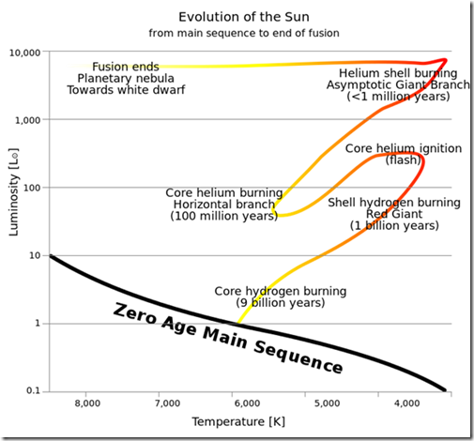

We’re going to be using this HRD of the sun’s path as a helpful visual. Again, the X-Axis is reversed and the Y-Axis is logarithmic.

## Main Sequence

From the start of fusion, the star lives on a portion of the graph we call the “Main Sequence”. This is where our sun is right now, and this is where stars spend the majority of their lives. The gravitational force pushing in on the star is counteracted by the radiative pressure of fusion at the core pushing out (hydrostatic equilibrium).

## Red Giant

As the fusion in the core continues (Hydrogen to Helium), Helium starts to condense and build up in the core of the star, forcing the Hydrogen fusion to take place in a shell around the new Helium core. The lack of radiative pressure in the core causes the core to contract under the force of its own gravity, while the fusion in the layer around it cause the rest of the star to expand into a red giant. Eventually, however, the Helium contracts so much that the force of friction ignites Helium fusion, causing a “Helium flash” and introducing the next element in the chain, Carbon, into the mix.

## Asymptotic Giant

The set of events that occurred with Helium now occur with Carbon, except that the star isn’t big enough (not enough Carbon) to initiate carbon fusion. In addition, Hydrogen and Helium fusion are still occurring in their respective layers. This means that the core will contract while the rest of the star expands, so much so that the rest of the star escapes the core’s gravity and drifts away in what we call a “planetary nebula”. What’s left is an inert carbon core that contracts into a white dwarf.